**NEO CULTURE TECH CLUB**

**Project Management Department**

**SUDOKU**

Design Proposal

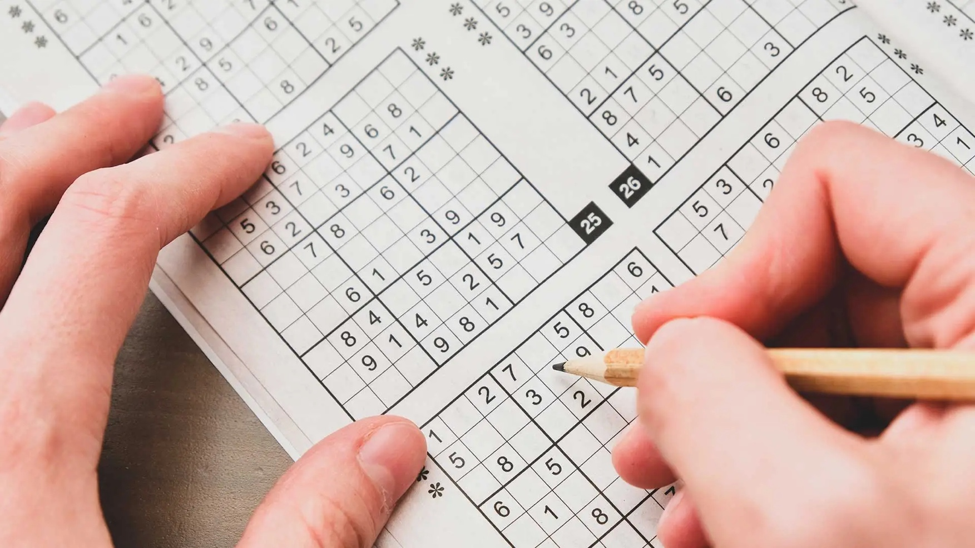

**Team Manager: Nguyen Son Tung**

**Team Member**

Table of Contents

1. Introduction 3

1.1 Background 3

1.2 Project Scope 3

1.3 Purpose 3

2. Problem Definition 3

2.1 Problem Statement 3

2.2 Solution 4

2.3 Design Requirements 4

**2.3.1. UI / UX 4**

**2.3.2. Difficulty 5**

**2.3.3. Hint System 5**

2.4 Constraints 5

3. Screening 6

3.1 Design Objectives 6

3.2 Weighting 6

3.3 Final Decision 6

4. Embodiment 6

4.1 Design Options 6

4.2 Bill of Materials 6

5. Risk Management 7

6. Gantt Chart 7

# **Introduction**

## **1.1 Background**

Throughout the semesters, we have acquired ourselves experience in creating both UI and BE components for games using Java and Python, including Xiang Qi – Chinese chess game and Flappy Bird. As a result, we have enough knowledge and confidence to create a customized Sudoku game that can meet the requirements and expectations.

Stakeholder:

* RMIT Neo Culture Tech Club
* Project Management Department
* NCT Members
* NCT Development Team

## **1.2 Project Scope**

**Table 1.1** Project Scope

|  |  |
| --- | --- |
| **In scope** | **Out of scope** |
| An intuitive overall UI/UX | Multiplayer gaming capabilities or online playing feature (e.g., online ranking board based on the solving time) |
| Multi-game difficulty | A mobile version of the game |
| Robust game hint system |  |

## **1.3 Purpose**

This project aims to bring people who enjoy coding into the club. First-year developers will have numerous opportunities to gain experience, use, and get used to these languages such as Java, HTML, etc. Ideally, this project can be used as a showcase item for the NCT club during the club day to promote and advertise itself.

# **2. Problem Definition**

## **2.1 Problem Statement**

As we understand it, the NCT club is a dynamic group that is actively involved in a variety of projects. While they have several current projects, it appears that a big portion of their attention is focused on Java projects, particularly large ones that need a great amount of time and effort. However, their dedication to Java projects demonstrates their commitment to delivering high-quality outcomes.

## **2.2 Solution**

For the problem above, the Sudoku project is an optimal solution. The project has the simplicity of the game algorithm and logic, GUI, and maintenance processes, which will enable our development team to work efficiently and expect a high-quality outcome which is a fully functional project that can perform well and response interactions quickly.

Furthermore, because this project is likely to be completed before the club day event, it is an ideal choice for exhibiting our club's strengths and attracting new members.

## **2.3 Design Requirements**

Additionally, Sudoku requires the design following these features:

### **2.3.1. UI / UX**

A separate section of the UI will display game controls, including buttons for generating new puzzles, submitting the solutions, providing hints, and taking notes in the grid. The UI also include a timer and a game-pause button that manage the time spent by the player and pause the game while solving.

**TAKING NOTE FEATURE**

**FULL GAMEPLAY UI / UX**

### **2.3.2. Difficulty**

Based on the common points in most games, Sudoku should contain a section in which players can select their desired difficulty (easy, medium, hard) with clear descriptions of what each level entails.

Thus, the game logic must include a Sudoku puzzle generator capable of creating puzzles of varying difficulty levels. The generated puzzles must always have a unique solution. The game should also validate the inputs in real-time by highlighting the incorrect input that conflicts with the logic (e.g., duplicate input in rows, columns, or 3x3 sub grids).

### **2.3.3. Hint System**

When it comes to hints, there should be an outstanding feature that reduces players’ boredom when playing games. Every time they ask for hints, there will be a small challenge (e.g., answering the riddles or questions). If they fail, no hint will be provided.

To summarize, this game provides users with a logic and thinking environment, allowing them to entertain themselves after work and increase mental activity and develop thinking.

**Q&A BOX**



## **2.4 Constraints**

Individual ability can be limited by their skills and experience. To be completed, it is necessary to ensure that the development team has a decent proficiency in programming using Java and related technologies. Lastly, a strong understanding in mathematics and computing algorithms is preferred as it will be used for generating the Sudoku puzzle as well as providing hints to users.

# **3. Screening**

## **3.1 Design Objectives**

|  |  |
| --- | --- |
| **Design Objective** | **Design Metric** |
| User-friendly Interface | * Visual appeal and consistency of UI element. * Availability and visibility for game-control buttons. |
| * Clarity and readability of the Sudoku 9x9 grid. |
| Interactive Game Control | * Provide clickable grids for number input. * Highlighting the incorrect input when submitting. |
| Multiple Levels of difficulty | * Implementation of 3 difficulty levels: Easy, Medium, Hard. |

## **3.2 Weighting**

|  |  |  |  |  |  |  |  |  |
| --- | --- | --- | --- | --- | --- | --- | --- | --- |
| **Design objective** | **Evaluation** | | | | | | **Sum of weighting** | **Weight Rate** |
| Tung | Quoc |  |  |  |  |
| **User-friendly Interface** | 40 | 30 |  |  |  |  | 70 |  |
| **Game Control** | 30 | 40 |  |  |  |  | 70 |  |
| **Level** | 40 | 25 |  |  |  |  | 65 |  |
| **SUM** | 100 | | | | | |  |  |

## **3.3 Final Decision**

# **4. Embodiment**

## **4.1 Design Options**

## **4.2 Bill of Materials**

|  |  |  |  |  |  |
| --- | --- | --- | --- | --- | --- |
| **No.** | **Potential Risk** | **Likelihood** | **Consequence** | **Risk Score** | **Mitigation** |
| 1 |  |  |  |  |  |

# **5. Risk Management**

|  |  |  |  |  |  |
| --- | --- | --- | --- | --- | --- |
| **Likelihood** | **Consequence** | | | | |
| **1**  **(Insignificant)** | **2**  **(Minor)** | **3**  **(Moderate)** | **4**  **(Major)** | **5**  **(Catastrophic)** |
| **5 (Almost certain)** | M | H | E | E | E |
| **4 (Likely)** | L | H | E | E | E |
| **3 (Moderate)** | L | M | H | E | E |
| **2 (Unlikely)** | L | L | M | H | E |
| **1 (Rare)** | L | L | L | L | H |

**> 11** E: Extreme risk; immediate action required.

**8 – 11** H: High risk; senior management attention required

**5 – 7** M: Moderate risk; management responsibility required

**1 – 4** L: Low risk; managed by routine operations

# **6. Gantt Chart**